**Cruise Recommendation and Favorability Prediction**

Problem Statement and Hypothesis

The client would like to understand how does the marketing spend in different marketing funnels impacted their brand image. My original question is: How does the customer attribution impacted the brand?

By utilize machine learning, I would like to use these attribution information to predict the probability of the customers’ probability to recommend the brand and increase favorability.

The hypothesis is that the probability of favorability will reach 80% when the subjects selected and are in favor of 50% of the attribution questions (Yes/No).

Data: What, When, Where, Why, How

It is a live survey data that feeds to the online banner ads. Once the person is exposed to the ad, we will send a link for them to fill the survey up. We are going to answer the data question above.

Data Structure:

Demographic Information (Age, Income, Career, etc)

The data is mostly on a scale either 0-5 or 0-10

* Demand Generation Question (1 question)
* Attribution Questions (10 Questions)
* Overall Consideration and Recommendation Questions (5 questions)
* Competitor Benchmarking Questions
* Current Data Structure: (2454,93)

Data Range:

* 1/20 to 5/3/2016

Below is the test and control setup, media strategy by layers, partner sites, and tech stack.

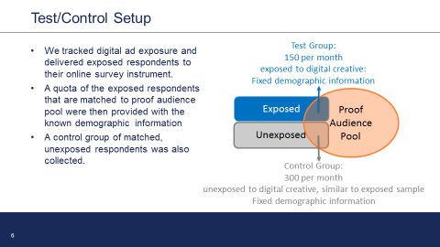

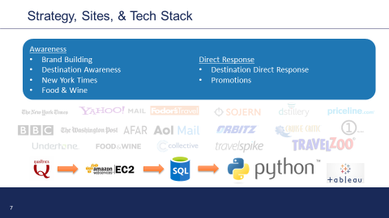

Below are the creatives involved in the testing.

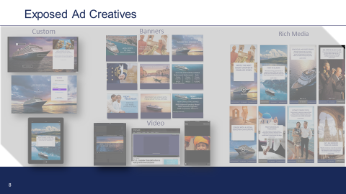

* Description of any pre-processing steps you took.
  + Features have a mixture of text and number, and have already processed most of the data into the right format.
* What you learned from exploring the data, including visualizations
  + Drive the data visualization from tableau
* How you chose which features to use in your analysis
  + I will ask the question. Does the data have some strong correlation between two features. If it does, then I will investigate further whether I would use it by running a regression. Does that improve how my model perform? If it does, I will look at how big of the impact it is? Not all will be added into the model.
* Details of your modeling process, including how you selected your models and validated them
  + Initial regression analysis to select the features, and the push the features into logistic regression. Split test and train them.
* Your challenges and successes
  + Successes:
    - The casual relationship of Welcoming, Favorability, various destinations has a strong relationship of cruise recommendation.
    - After training the data, the logistic regression has a 88% data fitness and the accuracy score is 86%
    - The false positive rate is 14%, which is lower than the false negative 29%. This is a good sign, because the rationale is that it’s important to keep the actual people that were supposed to sign up but did not. It would be good to manage the expectation.
  + Couple challenges:
    - The bundle of the attribution takes a long time to be figured out.
    - The data needs to be matched up with the reference table, and make it meaningful.
    - Can not change survey questions anymore.
    - Statistical significance (90%) can be a challenge at the beginning, and it’s not until middle of April.

**The Result:**

I failed my original hypothesis. It will take the participant to be in favor of 68% of the attribution questions so that they will reach an 80% chance of recommending the brand.

The original hypothesis was 50%.

**The Next Step:**

A/B Testing:

* Control Group: By utilizing normal site cookies, target them with specific ads and measure the conversion rate of signup.
* Test Group: By utilizing the cookie pools that the test collected (for those that would potentially recommend the brand), create a look-a-like cookie pool based on similar attribution. Finally target them with specific ads and measure the conversion rate of signups.

The hypothesis is that it would have at least 3x the lift in conversion rate and lower the cost per signups.

* Possible extensions or business applications of your project
  + Clustering and classifying the cookie data.